# Lab 5

Q. Compare a server-rendered application (e.g. PHP) - having its presentation layer in server-side logic - with a Rich-web approach (having is presentation layer as client-side logic). Mention two advantages of each approach

A. The benefits of a php server-rendered application is that these are used for mostly used in a website for displaying images and text, which means that there is little space for errors. There is little error for inactivity. Obviously this is becoming obsolete as continuous development has brought out the method of rendering pages on the client side. This is where the rich web approach comes into place. These are built using a server to provide continuous data processing on the client side. This enhances the webpage immensely and obviously makes the server rendered method a thing of the past.

Q. Explain how the box model works in CSS using example code in your answer

A. In the CSS box model as stated in the name each element is presented as a box as shown in the figure below from the slides.

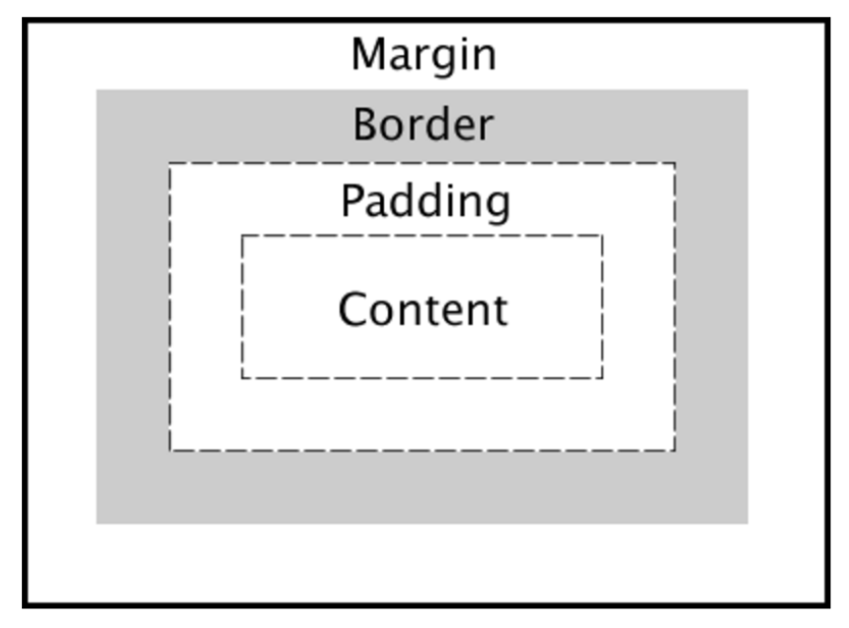

When a web page loads it renders the it works out what styles are used to the content of each box. It sees how big the surrounding layers are e.g. wrappers and where the boxes reside in relation to one another. Coding example below

div {

    width: 320px;  
    padding: 10px;  
    border: 5px solid black;  
    margin: 0;

}

Q. Suppose your web App has to run on an older browser that does not have built-in support for the fetch() API. Sketch an outline of how the fetch() API could be poly-filled in Javascript based on the XMLHttpRequest() API

A. To begin with this I would check the version of the browser you are using. If the browser is the older then use the Http request method using the Http request to go to the event target. As shown in the code below.

function httpGetAsync(URLhere, callback)

{

var xmlHttp = new XMLHttpRequest();

xmlHttp.onreadystatechange = function() {

if (xmlHttp.readyState == 4 && xmlHttp.status == 200)

callback(xmlHttp.responseText);

}

xmlHttp.open("GET", URLhere, true);

xmlHttp.send(null);

}

Q. CSS allows the reuse of code for styling DOM elements. Javascript functions can all be used for element styling and support code reuse. Compare the two code sharing approaches

A. CSS is used by a programmer to design a web page. It can be used to alter or design the page how the programmer sees fit. In Javascript for example a function can be created and information can be pulled from a user based website by asking URL. The URL could then be amended and the URL would pass the function to return a JSON object as seen in lab 2. When it runs it will first the information about the user of will be returned and then the information linked to said user. Like github used in lab 2.

Q. Describe the Web Component abstraction and explain its perceived advantages as a separation-of-concerns mechanism over other single responsibility approaches

A. In this component you can separate all aspects of a web page into their different components and If there are bugs the component can be removed and fixed the easily slotted back in this component also maintains a kind of MVC model.

Q. Describe how a React JS stateful class component is created and how its instantiated life-cycle can be managed

A. Components in react let you divide the UI into independent, reusable pieces and alter each piece as you like. It is created by accepting a “props” with data that returns a react element. To prolong lifecycles of the of the component it is imperative to look after the garbage disposal e.g. when components are destroyed. In react the functions componentDidmount and componentWillUnmount are used to accomplish this. Managing these correctly and handling the garbage disposal in an efficient manor the life-cycle can be optimised.

Q. In asynchronous programming, we have three approaches to handling data which may or may not arrive at some point in the future, namely callbacks, promises and streams. Describe each of these approaches. Are there any significant drawbacks of each in your opinion?

A. In relation to asynchronous programming callback functions implement the logic when you provide and I/O request and it will execute at the point when the request has been filled. Whenever the code needs to make a request that will take a long time to complete this when the callback method can be implemented. In relation to the browser it stores this function for execution. In relation to promises, these are values which are used to deliver said values when the response arrives and the value will either be a success or an error. These can also be passed into functions as arguments. In relation to stream these are abstractions used to model asynchronous data sources. If you don’t know the size or when it will arrive at your application the stream is an efficient way to process the data in these circumstances. Streams act like arrays e.g. ordered lists of data, they also implement the observer pattern.

Q. What are your reflections on how the Rich Web technologies stack up as a development environment based on your experience in this module or elsewhere?

A. In my experience I feel that the rich web approach is the way forward and in the technologic world of today is used over older technologies. Creating a social network web app in past experience using dropbox API it seemed to be very efficient in accomplishing this task and also included a lot of modules needed. It seems like the best way to create and develop applications be it alone or in a team. It provides may tools that boost the application in ways that would take an immense amount of time doing the old-fashioned way. Also, to install and run are quite simple to execute as well.

Q. You will have encountered many bugs and issues during your code development in this module’s labs. Describe your approach to debugging your javascript application, mentioning any tools or techniques you have used

A. While completing this lab I used Webstorm which is a powerful IDE and I used this for debugging when I ran into trouble. Also, I used the editor atom which allowed me to install packages needed for specific problems that I ran into if webstorm could not get the task done.